THE EFFECT OF WELCOME PLANT (Zamioculcas sp.) LEAVES EXTRACT AND DIATOMACEOUS EARTH ON MORTALITY TIME OF COCKROACHES (Blattodea sp.)

A Research Project Paper

Presented to

The Faculty of the Integrated Basic Education Department

Senior High School

Colegio de San Jose

Jaro, Iloilo City

In Partial Fulfilment

of the requirements in Research

by

Agacid, Bresias May O.

Elle, Vien Precious A.

Hallara, Elaizha Louise J.

Malan, Andrea Marie G.

Montaner, Kevin Benedict O.

12 - STEM 1 BLESSED ROSALIE RENDU

 April 2024

**Acknowledgement**

This research aims to explore the impact of the welcome plant leaves extract and diatomaceous earth against cockroaches. Before delving into our study, we would like to express our gratitude to those who have contributed to its realization. This study was made successful through the aid of significant persons who guided and helped the Researchers throughout the completion of the study.

First and foremost, the researchers would like to express their deepest appreciation to their research adviser, Ms. Leiza Jane Alianza, for her guidance, support and encouragement throughout the entire research process. Her feedback has been instrumental in shaping the direction and scope of this study.

The researchers are also grateful to their validators for sharing their expertise and opinions for the best outcome of this research paper. Their constructive feedback and thoughtful suggestions have significantly enhanced the quality of this study.

Lastly, they are grateful to the Almighty God for His strength and direction throughout this research project. Without His graces and blessings, this study would not have been possible.

Title Page

Acknowledgment I

Panel of Oral Examiners II

Approval sheet II Abstract II

Table of Contents VI

List of Tables IX

List of Figures IX

Chapter

1 Introduction 1

Background of the Study 1

Conceptual Framework 3

Research Paradigm 4

Statement of the Problem 5

Hypothesis 6

Significance of the Study 6

Definition of Terms 8

Scope and Limitation of the Study 7

2 Review of Related Literature and Studies 11

Welcome Plant (Zamioculcas sp.) 11

Pesticide 13

Cultivation of the Welcome Plant 14

Cockroach infestation 15

Extract of the welcome plant 17

Diatomaceous earth as Pesticide 17

Plant-based Pesticide 19

Synthesis 20

3 Research Methodology 22

Purpose of the Study 23

Research Design 23

Variables 24

Subjects 25

Procedures 25

Materials 26

4 Data Presentation, Interpretation and Analyses 32

**Average mortality time of Cockroaches** 33

**Difference in the mortality time of Cockroaches when Exposed to Different Treatments of Welcome Plant leaves extract and diatomaceous earth**

Summary, Conclusions and Recommendations

Summary

Conclusions

Recommendations

References 40

Appendices 47

A. Documentation 49

Researcher’s Profile

Chapter 1

**Introduction**

**Background of the Study**

In modern times, a considerable number of individuals encounter an issue involving a substantial population of cockroaches, both inside and outside their residential premises. These insects can contaminate food, kitchen utensils, and other household items, and emit an unpleasant odor *(Potter, 2018).*  Additionally, the excrement and shed skins of cockroaches may elicit an allergic response among several individuals.

A scavenging insect resembles a beetle, having long antennae and legs and typically a broad, flattened body. Several tropical kinds have become established worldwide as household pests. Cockroaches are pests that homeowners are worried about causing contamination and health problems. Cockroaches come from areas that harbor bacteria, such as bathrooms, drains, and dumpsters (Admin, 2019). These pests lay multiple eggs at one time in any place that is damp or hidden. They like to be close to food, crumbs, and spills. To get rid of them, some homeowners create a plan on how to remove these pests since they can affect health in several ways.

There are a lot of commercial products that can get rid of cockroaches but many of them can cause poisoning after being swallowed, or inhaled, and can irritate skin and eyes. The researchers wanted to find a natural and organic alternative to commercial pesticides.

Zamioculcas, also known as the Welcome Plant or ZZ Plant, is a popular houseplant due to its glossy, evergreen foliage. They are easy to maintain and are good at purifying the air. They can also be grown in pots in limited conditions. These plants belong to the genus of flowering plants in the family "Araceae" (Plant Kingdom UAE, 2022). Therefore, this research can help households reduce the population of cockroaches.

Diatomaceous earth, also known as diatomite, is a soft sedimentary rock that occurs naturally. It can be crumbled into a fine white or off-white powder and is composed of the fossilized remains of hard-shelled microalgae called diatoms. The powder contains about 80%-90% silica and is believed to kill insects by dehydrating or drying them out. Additionally, the powder allows liquids to pass through while trapping unwanted particles (WebMD, 2020).

    This research aims to produce an alternative pesticide made of Welcome Plant (*Zamioculcas sp*.) leaves extract and Diatomaceous earth. It aims to study the comparison of Organic Pesticide to commercial pesticides. The researchers wanted to find the efficacy that can help homeowners lessen the number of cockroaches inside their houses.

**Conceptual Framework**

The study aims to determine the effect of Welcome plant leaves extract and Diatomaceous earth on the mortality time of cockroaches (*Blattodea sp*.). In this study, the independent variables are the different proportions of Welcome plant leaves extract and Diatomaceous earth, while the dependent variable is the mortality time of cockroaches and the positive control and negative control. The paradigm shows how the different proportions of welcome plant leaves extract and diatomaceous earth can affect the mortality time of cockroaches, as seen in Figure 1.

**Research Paradigm**

***Figure 1.*** The Effect of the Welcome plant (*Zamioculcas sp.*) leaves extract, Diatomaceous and control group on the mortality time of Cockroaches (*Blattodea sp.*).

**Statement of the Problem**

This study aimed to determine the mortality time time of cockroaches (*Blattodea sp.*)  after being exposed to welcome plant leaves (*Zamioculcas sp.*) extract and diatomaceous earth.

Specifically, this study sought to answer the following questions;

1. What is the mortality time of cockroaches (*Blattodea sp.*) when exposedto the different proportions of Welcome plant (*Zamioculcas sp.*) leaves extract, diatomaceous earth, and the control?
2. Is there any significant difference in the mortality time of cockroaches (*Blattodea sp.*) when exposed to the different proportions of the welcome plant (*Zamioculcas sp.*) leaves extract, diatomaceous earth, and the control?

**Hypothesis**

Based on the foregoing questions, the hypothesis was formulated;

1. There is no significant difference in the mortality time of cockroaches when exposed to different proportions of Welcome plant (*Zamioculcas sp.*) leaves extract, diatomaceous earth and the control.

**Significance of the Study**

The result of this study will be beneficial to the following:

**Homeowners**. The results of this study will provide an alternative, safe and effective way to control cockroaches in homes and apartments without the use of harmful chemicals.

**Manufacturers.** The result of this study will help the manufacturers generate a new and sustainable formula for their products based on the information about welcome plants and diatomaceous earth against cockroaches.

**The Community.** The results of this study will provide the community with a practical and sustainable option for commercial pesticides.

**Future Researchers.** This conducted study will open doors for future researchers to refine and expand on experiments about the efficacy of the welcome plant in reducing the population of cockroaches. This research could serve as valuable information on the efficacy of the welcome plant and diatomaceous earth as an alternative pesticide for cockroaches.

**Scope and limitation**

This experimental study aimed to determine the efficacy of welcome plant leaves extract and diatomaceous earth on the mortality time of cockroaches (*Blattodea sp.*). This study was limited only to the efficacy of welcome plant (*Zamioculcas sp.*) leaves extract and diatomaceous earth. The experiment focused only on the mortality time of cockroaches due to the efficacy of Welcome plant (*Zamioculcas sp.*) leaves extract and Diatomaceous earth.

The experiment was conducted on March 21, 2024. The experiment was performed by the researchers at Colegio de San Jose’s science laboratory. The Welcome plant (*Zamioculcas sp.*) leaves extract was gathered from the garden and diatomaceous earth was purchased from the store of one of the researchers. Meanwhile, the cockroaches (*Blattodea sp*.) were also bought from the shop near the PNB old building. In this study, 5 different treatments were used, including the control. 75 cockroaches were used in this study. The researchers used Mean, Standard Deviation, ANOVA, and Tukey HSD-Post Hoc test for statistical analysis.

**Definition of Terms**

For clarification and understanding, the following terminologies were hereby defined conceptually and operationally.

**Cockroach.** A scavenging insect resembles a beetle, having long antennae and legs and typically a broad, flattened body. Several tropical kinds have become established worldwide as household pests (Merriam Webster, 2024).

In this study, these referred to the 75 subjects of the study that were exposed to the different proportions of treatments of welcome plant (Zamioculcas sp.) leaves and diatomaceous earth.

**Diatomaceous Earth.** Diatomaceous earth is made from the remains of diatoms, which are tiny organisms that live in rivers, streams, lakes and oceans. Diatom skeletons are made up of silicon dioxide, a combination of silica and oxygen**.** It is very abrasive to an insect's exoskeleton, causing them to dry out and die (National Pesticide, 2023).

In this study, diatomaceous earth referred to a powder that was mixed with the welcome plant leaves extract.

**Extract.** is to withdraw something, such as a juice or a constituent element by a physical or chemical process (Merriam-Webster Dictionary, 2024).

In this study, extract from Welcome Plant (Zamioculcas sp.) leaves extract is used to test the mortality time time of cockroaches.

**Infestation.** the presence of a huge number of insects or animals in a place, typically to cause damage or disease (Petri Pest Control Services, Inc., 2024).

In this study, Infestation refers to the amount of cockroaches that carry disease in a certain place.

**Mortality time.** the ratio of deaths occurring in a certain time in a given population to the number of individuals in the population. (Merriam Webster, 2024)

In this study, the mortality time refers to the amount of dead cockroaches in a certain time.

**Pesticides.**  a [chemical](https://dictionary.cambridge.org/dictionary/english/chemical) substances used to [kill](https://dictionary.cambridge.org/dictionary/english/kill) [harmful](https://dictionary.cambridge.org/dictionary/english/harm) [insects](https://dictionary.cambridge.org/dictionary/english/insect), [small](https://dictionary.cambridge.org/dictionary/english/small) [animals](https://dictionary.cambridge.org/dictionary/english/animal), [wild](https://dictionary.cambridge.org/dictionary/english/wild) [plants](https://dictionary.cambridge.org/dictionary/english/plant), and other [unwanted](https://dictionary.cambridge.org/dictionary/english/unwanted) [organisms](https://dictionary.cambridge.org/dictionary/english/organism) (Britannica, 2024).

In this study, organic pesticides will reduce the number of cockroaches.

**Silica.** is a hard, unreactive, colorless compound which occurs as the mineral quartz and as a principal constituent of sandstone and other rocks (Britannica, 2024)

In this study, Diatomaceous earth contains 80%- 90% Silica.

**Welcome Plant (*Zamioculcas sp.*).** Zamioculcas zamiifolia Also known as Welcome plant or ZZ Plant are excellent houseplants and are popular for their glossy green evergreen foliage (Plant Kingdom UAE, 2022).

In this study, the Welcome plant leaves extract will be used as an independent variable to reduce the subject population as they have a potential effects against cockroaches.

Chapter 2

**Review of Related Literature and Studies**

This chapter reviews the concepts and research literature relevant to this study.

**Welcome Plant (Zamioculcas sp.)**

Welcome plants (*Zamioculcas sp.*), also known as the ZZ plant, have been studied for their potential effects against cockroaches. One study found that Jatropha curcas seed oil, when tested against adult American cockroaches (PME Ubulum,2021), showed repellent and insecticidal properties, reducing the population of Periplaneta americana. Another study focused on the ability of Z. This method could be used to create new plant types with attractive features. Welcome plant contains unusually high-water contents of leaves (91%) and petioles (95%) and has an individual leaf longevity of at least 6 months which may be the reason it can survive extremely well under interior low light levels for 4 months without water.However, the Welcome Plant has calcium oxalate crystals in its sap, which makes it part of the list of poisonous houseplants. While not all parts of the plant are considered toxic, the spikes of its leaves or the sap can irritate your pet's mouth, esophagus and digestive system. Additionally, pests can be poisoned by the natural compounds in the Welcome Plant that they find unpleasant or even harmful. This is considered an organic pesticide rather than the usual pesticides that can poison humans if they accidentally ingest them (Worth, 2024).

The Welcome plant is part of the Araceae family which is well known for its many poisonous genera which can make use as pest repellent against cockroaches, such as Philodendron, which contains calcium oxalate. Needle-like calcium oxalate crystals could irritate different sensitive skin parts, mucosa, conjunctiva and especially insects like cockroaches, mosquitoes, ants and beetles.(Rosell, 2021)

Extreme versions of this rumor claimed that the plant could cause cancer and was even dangerous to touch, leading people to wear gloves when handling it, even making a pest repellant can be more dangerous because it can make that extract as a candle, spray, or naphthalene ball to reduce the numbers of cockroaches that we will experiment.

An initial toxicological experiment conducted by the University of Bergen in 2015 on extracts from the Welcome plant using brine shrimp as a lethality inspection did not indicate lethality to the shrimps even at proportion of treatment of extracts up to 1 mg/mL, providing disproving evidence for the assumption of Welcome plant toxic character. The scientists experimenting found that "On the contrary, it could appear as though the extract contributed to improvements in the vitality of the larvae".

**Pesticide.**

       Research has been conducted in various forms. One study focuses on a pest-repelling device that uses a temperature sensor to ensure optimal operation and extend the device's service life. Another study explores an insect-repellent air freshener made from natural ingredients such as citronella oil, ginger oil, and garlic oil, This air freshener not only dispels odor but also repels mosquitoes and insects. A study presents a noxious insect repellent that effectively repels the spreading of ants. Additionally, a pest-repellent polymeric composition has been developed, which includes a thermoplastic polymer and a silica carrier with absorbed pest-repellent activity. This composition can be used to create various pest-repellent articles. Lastly, a pest-repelling adhesive tape has been developed, which contains a fabric with a repellent, a protective layer, and an adhesive layer (Connell, 2016).

**Cultivation of the Welcome Plant**

    The Welcome plant is a popular ornamental plant known for its attractive glossy foliage. It can be grown outdoors, but the temperature should not fall below 15°C (59°F). The optimal growth temperature for this plant is between 18°C to 26°C (65°F to 79°F), with hot temperatures increasing leaf production. In temperate regions, the Welcome plant is commonly grown as a houseplant. It is important to avoid over-watering, as it may lead to tuber rot. It is better to err on the side of dryness. Avoid using leaf shiners on this plant. For potted specimens, a quarter or eighth-strength liquid fertilizer such as fish emulsion, worm-cast liquid, or naphthalene ball for cockroaches may be used once a month during the warmest period. Bright, indirect light is best for the Welcome plant, although it can tolerate light levels as low as 270lx (25 FC), which is equivalent to the light 70cm away from a 100W incandescent light bulb. It can tolerate some sun, but only very early in the morning for hot districts, and morning or afternoon for cooler districts (Chan, 2015).

    It is possible to propagate a welcome plant by using leaf cuttings. To do this, you should take the lower part of a detached leaf and place it into a moist and gritty compost. Then, put the pot inside a polythene bag. Even though the leaves may decay, small and fleshy bulb-like structures should form in the compost. These structures can be potted up to create new plants. However, this process may take at least a year.

**Cockroach Infestation**

     Cockroaches are resilient insects with a thousand pests worldwide that habitually occupy narrow crevices, such as those behind refrigerators, under sinks, or cabinets. Owing to their large colonies, which feature numerous foraging workers, cockroaches exhibit a notable adaptability to their surroundings. According to Gondhalekar et al. (2021), the presence of domestic cockroaches presents a multifaceted public health problem. Cockroaches Infestation is a significant concern due to its association with poor sanitation and potential public health impacts. Research suggests that cockroaches may serve as potential vectors for pathogenic bacteria, including antibiotic-resistant strains, therefore it is crucial to understand the growth and adaptive mechanism of cockroaches (Albert, 2016). Beyond their material damage and aesthetic repulsion, these resilient pests can trigger allergic sensitization and worsen the existing asthma in susceptible individuals. Furthermore, infestations can be a significant source of psychological stress and social stigma for residents. Cockroach infestation is a prevalent issue in various communities, with studies highlighting its association with poor sanitation. Different species like Blattella germanica and Periplaneta americana are commonly found in infested areas. The presence of cockroaches can lead to health concerns, as they are known vectors of diseases (Wannigama, 2014). Effective control measures, including the strategic application of pesticides, are crucial in managing cockroach populations and preventing the development of drug-resistant sub populations. Cockroach infestations have been linked to increased chances of atopic asthma, emphasizing the importance of proper extermination to reduce allergens and asthma prevalence in households. Addressing cockroach infestation through awareness, sanitation improvement, and targeted control strategies is essential for public health and well-being.

**Extract of the Welcome Plant**

      In this study, a pest-repellent material was synthesized using the extract from the leaves of the Welcome plant (*Zamioculcas sp.*), which has a high-water content of 91% in the leaves and 95% in the petiole. The complex background of natural scenes makes it difficult to extract the leaves from the plant, so the Closed-form algorithm was introduced in this technique to guide the extraction process and improve the procedure. The extracted leaves of the welcome plant contain a toxic substance that can be used as a pesticide against cockroaches. Extract from the welcome plant leaves (*Zamioculcas sp.*) have been studied for their phytochemistry and biological activities. The roots of Z. zamiifolia were extracted using n-hexane, chloroform, and methanol and the extracts were screened for their major components (Muharini, 2018).

**Diatomaceous Earth as Pesticide**

Diatomaceous earth is a natural substance that comes from the fossilized remains of tiny aquatic organisms known as diatoms. These organisms have skeletons made of silica that accumulate over time in the sediment of rivers, streams, lakes, and oceans. The grain industry needs to reduce its reliance on synthetic pesticides, resistant populations and insecticide residues in food and the environment. Diatomaceous Earth particles from silica minerals formed by the fossilization of green algae(diatoms), have been successfully proven for many years to have very strong insecticidal effects and could provide chemical resistance-free and environment-friendly pest control (Korunic, 2017). Diatomaceous earth has shown promising insecticidal properties against stored grain pests. Studies have demonstrated the effectiveness of diatomaceous earth formulations enhanced with botanicals and microorganisms like fungi in controlling pests such as grain beetle, american wheat, and red-flour beetle (Paponja, 2020). Moreover, it has been found to induce high mortality time rates in insects like Hide beetles, with significant effectiveness even at low doses. Natural formulations based on diatomaceous earth have shown higher efficacy compared to diatomaceous earth alone, with notable progeny inhibition in insect populations like Rice Weevil, Rhyzopertha dominica, and Red-flour beetle (Afgrafioti, 2023).

**Plant-based Pesticide**

Cockroaches are a common sight in human accommodations. Out of the 4600 species of cockroaches, 50 of them are associated with human living spaces.

The harmful effects, persistent nature, and environmental hazards of synthetic insecticides demand eco-friendly alternatives. The integrated pest management (IPM) approach is suggested. IPM employs a variety of technologies; one of them is the usage of plant-based insecticides to control household insect pests. Different studies have been conducted to control cockroaches using plant extracts, essential oils, and plant-based products. The control of cockroaches through plants and plant-based products is cost-effective, eco-friendly, and safe. Different plant parts such as leaf, stem, seed, flower, and rhizome extract have been investigated for their insecticidal activities against cockroaches.

Most studies were done on two cockroach species, Periplaneta americana and Blattella germanica, which were successfully controlled through the use of plants.

Due to indiscriminate use of synthetic pesticides over the years, several issues have come along, such as pest resistance and contamination of important planet sources, such as water, air and soil. Therefore, in order to improve efficiency of crop production and reduce food crisis in a sustainable manner, while preserving consumer's health, plant-based pesticides may be a green alternative to synthetic ones. They are cheap, biodegradable, eco friendly and act by several mechanisms of action in a more specific way, suggesting that they are less of a hazard to humans and the environment. Natural plant products with bioactivity toward insects include several classes of molecules, for example: terpenes, flavonoids, alkaloids, polyphenols, cyanogenic glucosides, quinones, amides, aldehydes, thiophenes, amino acids, saccharides and polyketides (which is not an exhaustive list of insecticidal substances). In general, those compounds have important ecological activities in nature, such as: antifeedant, attractant, nematicide, fungicide, repellent, insecticide, insect growth regulator and allelopathic agents, acting as a promising source for novel pest control agents or biopesticides. However, several factors appear to limit their commercialization. In this critical review, a compilation of plant-derived metabolites, along with their corresponding toxicology and mechanisms of action, will be approached, as well as the different strategies developed in order to meet the required commercial standards through more efficient methods.(Souto,2021)

**Synthesis**

This study focused on synthesizing the effect using the extract from the leaves of the Welcome plant and diatomaceous earth. The extract from the Welcome plant (*Zamioculcas sp.*) leaves has a high water content of 91% in the leaves and 95% in the petiole. Extracting the leaves from the plant is a challenging task due to the complex background of natural scenes. To overcome this, the Closed-form algorithm was introduced in this technique, which is a set of rules that guides the extraction process and improves the method. Our extracted Welcome plant leaves and diatomaceous earth contain a toxic substance that can be used as an alternative to commercial pesticides against cockroaches.

This study aimed to evaluate the methods used for preparing the Welcome plant (*Zamioculcas sp.*) leaves and diatomaceous earth that causes the insects to dry and die, to create a pesticide against cockroaches, which are used in our daily research. While the focus of this study is on cockroaches, eco-friendly nature of utilizing plant leaves substances derived of different proportions that applied. And it may help to reduce the number of cockroaches in any inch of our households.

Chapter 3

**Research Methodology**

This chapter presents the purpose of the study, research design, data-gathering procedures, data analyses, and statistical tools employed to determine the Effect of the Welcome plant leaves extract and diatomaceous earth against cockroaches.

**Purpose of the Study**

The purpose of this study is to determine the effect of the welcome plant (*Zamioculcas sp.*) leaves extract and diatomaceous earth. By investigating the Effect of Welcome plant (*Zamioculcas sp.*) leaves extract and diatomaceous earth, researchers seek eco-friendly alternatives to commercial pesticides, considering the plant's properties and impact on cockroaches' mortality time. It involves assessing the effect of the plant's properties against cockroaches, potentially offering a natural and eco-friendly solution compared to commercial pesticides.

**Research Design**

This study is a true experimental design structured to investigate the Effect of the welcome plant (*Zamioculcas sp.*) leaves extract and diatomaceous earth on the mortality time cockroaches. The primary objective of this research is to assess whether the leaves extract of the welcome plant affects the mortality time of cockroaches. There were five replications conducted, and each replication had three cockroaches. In the control groups, the researchers used a commercial pesticide as the positive control. Meanwhile, for the experimental groups, the researchers prepared three treatments. Treatment A consists of 50% of the welcome plant (Zamioculcas sp.) leaves extract and 50% diatomaceous earth; Treatment B consists of 100% welcome plant (Zamioculcas sp.) leaves extract; and Treatment C, 100% of diatomaceous earth. Each group had five replications, with 3 cockroaches (Blattodea sp.) for each replication, to test the pesticidal effect of the welcome plant (Zamioculcas sp.) leaves extract and diatomaceous earth by measuring the average mortality time of cockroaches in each group.

**Variables of the Study**

The study investigates the Effect of welcome plant (*Zamioculcas sp.*) leaves extract and diatomaceous earth against cockroaches (*Blattodea sp.*). To gather data, the researchers conducted an experiment to determine the Effect of the welcome plant (Zamioculcas sp.) leaves extract and diatomaceous earth on the mortality time of cockroaches. The researchers purchased cockroaches to be used as test subjects for the experiment. An Observation Sheet was used to record the number of cockroach deaths after being exposed to various treatments of the welcome plant (Zamioculcas sp.) leaves extract and diatomaceous earth. The sheet also recorded the time taken for the cockroaches (Blattodea sp.) to die after the application of different proportions treatments.

**Subjects of the Study**

The study investigated the potential of two natural substances, Welcome Plant (*Zamioculcas sp.*) leaves extract and Diatomaceous Earth, as a practical alternative to chemical pesticides against cockroaches (*Blattodea sp.*). The research explores the Effect of these treatments against cockroaches, aiming to determine their effectiveness.

**Data Gathering Procedures**

To gather data, the researchers conducted the experiment to determine the Effect of welcome plant leaves extract and diatomaceous earth against cockroaches. The researchers purchased cockroaches to be used as test subjects for the experiment. An Observation Sheet was used to record the number of cockroach mortality time after being exposed to various treatments of the welcome plant (Zamioculcas sp.) leaves extract and diatomaceous earth. The researchers also recorded the time in order to determine the Effect of welcome plant leaves extract, diatomaceous earth, and the mortality time of cockroaches.

**Materials**

These are the following materials that were used in the study:

* 5 pieces spray bottles 
* 2 pieces Mortar & pestle
* Water
* 75 pieces cockroaches
* Digital weighing scale
* 1 large glass container
* 25 Plastic cups
* Cloth

**Procedures**

**I. Gather the Materials**

During this stage, the researchers purchased 75 live cockroaches and the diatomaceous earth from a store. Then, two researchers collected the Welcome plants from their garden. The leaves of the Welcome plant were then gathered using gloves and scissors. The researchers borrowed other materials such as beaker, mortar and pestle, and lab gowns from Colegio de San Jose Science Laboratory and brought the rest, while some were already available at the researchers' home.

**II. Preparation of the Materials**

In this stage, the researchers prepared the necessary materials to make an extract out of Welcome Plant leaves. While diatomaceous earth was dissolved in water. To extract the contents of the welcome plant leaves, the researchers collected the leaves of the Welcome plant, cut them, and mashed them using a mortar and pestle. After that, the mashed leaves were placed into a clean cloth, and gloves were used to extract the contents from it. Using a beaker and weighing scale, the researchers prepared the different proportions of the Welcome plant leaves extract and diatomaceous earth required for the mixture.

**III. Conduct of Experiment**

In this stage, the researchers conducted the experiment using the following proportions of treatments. Treatment A consisted of 50% Welcome Plant leaves extract and 50% diatomaceous earth, Treatment B consisted of 100% Welcome plant leaves extract, Treatment C consisted of 100% diatomaceous earth.

After completely mixing these different proportions of the treatments, the researchers then sprayed the mixture on the subjects.

**IV. Application of Treatments to Cockroaches**

The researchers sprayed each treatment on the designated 5 replicates containing 3 cockroaches each. Treatment A consisted of 50% Welcome Plant leaves extract and 50% diatomaceous earth, Treatment B consisted of 100% Welcome plant leaves extract, Treatment C consisted of 100% diatomaceous earth, these treatments were sprayed on the designated replicates gradually every 15 minutes.

**V. Observation on the Subjects**

In this stage the researchers observed and found out which among the three different proportions of treatment including the control has the Effect based on the mortality time time during and after treatment applications on the subjects, based on the observation results the researchers draw out conclusions as to which treatment has Effect against cockroaches.

**VI. Analysis of Data**

The data obtained from the study were treated statistically in two ways: descriptive and inferential data analysis.













***Figure 2.*** *The General Procedure*

**Data Analyses**

The researcher gathered, organized, computed and tabulated the data. Computations, analyses, and interpretations were done using the computer with Statistical Package for Social Sciences (SPSS) version 2.6 software.

**Statistical Tools**

The effects of pesticide based on welcome plant leaves (Z*amioculcas sp.*) and diatomaceous earth in terms of length and number of cockroaches. With Three (3) treatments including the control, which are Treatment A consist of 50% of welcome plant leaves extract and 50% of diatomaceous earth, Treatment B consist of 100% of welcome plant leaves, Treatment C consist of 100% of diatomaceous earth along with control group of commercial spray. That can lead to different results of proportion.

**Mean.** The mean was used to determine the average results gathered from the One-way ANOVA t-test and SPSS. and the mean of the independent variable with three (3) treatments and the control variable proportions to determine the effectiveness in cockroaches

**Standard Deviation.** The standard deviation was used to determine the spread and variability of the measured data values from the results of the three (3) treatment applications and a control in relation to the acquired mean values of welcome plant (Zamioculcas sp.) leaves and diatomaceous earth.

**One-way Analysis of Variance (ANOVA).** It used to identify the result of three (3) treatments that consist of welcome plant leaves extract and diatomaceous earth, and the control group consisting of positive control for cockroaches if it is set at 0.05 level of significance overall.

       **Tukey HSD-Post Hoc Test.** It determines which groups or variables are means of the Effect of welcome plant leaves and diatomaceous earth are different all in all set at 0.05 level of significance.

Chapter 4

**Data Presentation, Interpretation and Analyses**

This chapter consists of two which are (1) Descriptive Data Analysis and (2) Inferential Data Analysis.

Part One, Descriptive Data Analysis, presents the table to answer the specific problem of the mortality time of cockroaches (Blattodea sp.) given the different proportion of the Welcome Plant (Zamioculcas sp.) and diatomaceous earth and the control.

Part Two, Inferential Data Analysis, presents the analysis and interpretations of data which will be used to test the hypothesis of the study. This part shows the result Analysis of Variance (ANOVA) and multiple comparisons.

**Descriptive data Analysis**

**Average mortality time of Cockroaches (Blattodea sp.)**

Table 1, shows the average mortality time time of cockroaches when exposed to the different treatments, Treatment A consists of 50% welcome plant leaves extract and 50% diatomaceous earth, Treatment B consists of 100% Welcome Plant Leaves extract, Treatment C consists of 100% diatomaceous and the positive and negative control. Based on the results, revealed that the Positive Control acquired the lowest mean of 0.31 interpreted as “Extremely Effective” with a Standard Deviation of 0.02, while Negative control has the highest in overall results that earned a mean of 50.00 with a Standard Deviation of 0.00 interpreted “Not Effective”. Among the Treatments, Treatment B gained the lowest mean of 21.76 with a standard deviation of 22.63 interpreted as “Moderately Effective”. On the other hand, Treatment A and Treatment C had the highest overall results. Treatments A and C gained a mean of 45.66 “Not effective” and 46.53 “Not Effective” and a Standard Deviation of 11.47 and 9.14.

**Table 1.** mortality time of Cockroaches upon being exposed with the different proportions of the Welcome Plant (Zamioculcas sp.) and diatomaceous earth and the control.

| Treatment | N | Mean | Std. Deviation | Description |
| --- | --- | --- | --- | --- |
| Treatment A | 15 | 45.66 | 11.47 | Not Effective |
| Treatment B | 15 | 21.76 | 22.63 | Moderately Effective |
| Treatment C | 15 | 46.53 | 9.14 | Not Effective |
| Positive Control | 15 | .31 | .02 | Extremely Effective |
| Negative Control | 15 | 50.00 | .00 | Not Effective |
| Legend  Scale of Means Description  0.01 - 9.53 Extremely Effective  9.54 – 19.07 Moderately Effective  19.08 – 28.61 Somewhat Effective  28.62 – 38.15 Somewhat Effective  38.16 – 50.00 Not Effective | | | | |

**Inferential Results**

**Difference in the mortality time of Cockroaches when Exposed to Different Treatments of Welcome Plant (Zamioculcas sp.) leaves extract and diatomaceous earth**

The following table provides an answer to the 2nd statement of the problem: Is there a significant difference in the mortality time of cockroaches (*Blattodea sp.*) when exposed to the different proportion of welcome plant (*Zamioculcas sp.*) leaves extract, diatomaceous earth, and the control. To analyze the data, one-way analysis (ANOVA) was used. According to Table 2, there were significant differences in the mortality time time of cockroaches across the three treatment groups and the control, with a result of p = 0.00. Since the p-value (0.000) is lower than the alpha level (0.05), the null hypothesis was rejected. Therefore, the decision was made to reject the null hypothesis.

**Table 2.** The Difference in the mortality time of Cockroaches (blattodea sp.) when Exposed to Different Treatments of Welcome Plant (Zamioculcas sp.) and diatomaceous earth.

| Category | df | F-Value | p-value | Remarks |
| --- | --- | --- | --- | --- |
| mortality time of Cockroaches | 4 | 47.06 | .00 | Significant |
| P<0.05, significant | | | | |

**Differences in the Mean of Each Treatment of Welcome Plant Leaves extract and diatomaceous earth**

Table 3 shows the significant difference of the mean of each treatment. Since One-Way ANOVA result reject the null hypothesis, Tukey HSD was utilized to determine the occurrence of the significant differences between the treatments. The data displays that Treatment A has no significant difference in Treatment B (p= 0.76), Treatment C (p= 0.99), Positive Control (p= 0.913) and Negative Control (p= 0.000). Treatment B has no significant difference in Treatment A (p=.76), Treatment C (p= 0.92), Positive Control (p= 0.26), and Negative Control (p= 0.000). Treatment C has no significant difference in Treatment A, Treatment B, Positive Control and Negative Control. Treatment C has no significant difference in Treatment A (p= 0.99), Treatment B (p= 0.92), Positive Control (p= 0.74) and Negative Control (p= 0.00). Positive Control has no significant difference in Treatment A, Treatment B, Treatment C and Negative Control. While Negative Control has significant differences in Treatment A, Treatment B, Treatment C and Positive Control.

**Table 3.** The Differences of the mean of each proportion of Treatments of Welcome Plant Leaves Extract and Diatomaceous earth.

| Category | Treatments | Treatments | p-value. |
| --- | --- | --- | --- |
| mortality time of Cockroaches | Treatment A | Treatment B | .76 |
|  | Treatment C | .99 |
|  | Positive Control | .91 |
|  | Negative Control | .00 |
|  | Treatment B | Treatment A | .76 |
|  | Treatment C | .92 |
|  | Positive Control | .26 |
|  | Negative Control | .00 |
|  | Treatment C | Treatment A | .99 |
|  | Treatment B | .92 |
|  | Positive Control | .74 |
|  | Negative Control | .00 |
|  | Positive Control | Treatment A | .91 |
|  | Treatment B | .26 |
|  | Treatment C | .74 |
|  | Negative Control | .00 |
|  | Negative Control | Treatment A | .00 |
|  | Treatment B | .00 |
|  | Treatment C | .00 |
|  | Positive Control | .00 |
| *The mean difference is significant at the 0.05 level | | | |

**Chapter 5**

**Summary, Findings, Conclusions and Recommendations**

Chapter V consists of three parts: (1) Summary of the Problem and Findings, (2) Conclusions; and (3) Recommendations.

Part one, Summary of the Problems and Findings reflect the results.

Part two, Conclusions, presents the inferences drawn from the findings of the study.

Part three, Recommendations for the future research, suggest possible ways of conducting future studies based on the findings of the investigations using other variables.

**Summary**

This quantitative true-experimental study aimed to determine the Effect Welcome plant leaves extract against Cockroaches and its potential as an alternative to commercial pesticides given different proportions of treatments. The study was conducted last March 21, 2024, at Colegio de San Jose. This quantitative inquiry focuses only on the mortality time of Cockroaches given different treatments of Welcome Plant Leaf extract. The data retrieved from this study were analyzed using computer processing software which is the Statistical Package for Social Sciences (SPSS) version 2.6, the data was retrieved and studied. The One-way Analysis of Variance (ANOVA) was used to determine if there is a significant difference in the mortality time of cockroaches, and Tukey HSD Post-Hoc was utilized, to determine the distinctions between groups. After the researchers studied the data, the data shows that in the mortality time of Cockroaches Negative control gained the highest mean of 50.0000 which means it is (Not Effective) and a standard deviation of .00000, and the Positive Control had the lowest in overall results that acquired the mean of .3167 and a Standard deviation of .02440. Hence, among the Treatments for the Treatment A has a mean of 45.6667 which means that is (Not Effective), and it has a standard deviation of 11.47461. Treatment B has a mean of 21.7667 which means that is (Moderately Effective), and has a Standard Deviation of 22.63599. Treatment C has a mean of 46.5333 which means that is (Not Effective), and it has a standard deviation of 9.14851. Positive Control has a mean of .3167 which means that is (Extremely Effective), and has a Standard deviation of .02440. Negative Control has a mean of 50.0000 which means that is (Not Effective), and it has a Standard deviation of .00000. By comparing the effectiveness of the different treatments and the control, it can be affirmed that there is a significant difference between Treatment B and Positive Control to the different treatments. The results from One-Way ANOVA showed that the p-value is .000 which means there is a significant difference in the mortality time of Cockroaches when exposed to different proportions of Welcome Plant leaf extract.

**Conclusion**

Based on the results of the study, the following conclusion was drawn: Welcome Plant Extract and Diatomaceous Earth can be an alternative to commercial pesticide. The different treatment such as: Treatment A that consist of 5 ml Welcome Plant leaves extract and 5 ml Diatomaceous Earth with a mean of 45.667 extract, Treatment B that consist with a mean of 21.766 Welcome Plant leaves extract, and Treatment C with a mean of 46.533 Welcome Plant Leaves extract had shown pesticidal property. And the positive and negative control with the mean of .31 and 50.00 and Standard Deviation of .02 and .00. Based on Table 2, the 3 proportional treatments showed that there were significant differences on the mortality time of cockroaches and the control with a result of p-value=0.00. Therefore, the null hypothesis is rejected because the p-value of 0.00 is lower than the alpha level (0.05). Based on Table 3 the Tukey HSD was utilized to determine the occurrence of the significant differences between the treatments. The data displays that Treatment A has no significant difference in treatment (B=0.76), Treatment C (p=0.99), Positive Control (p=0.913) and negative control (p=0.000).

**Recommendation**

Based on the findings and conclusions, derived from the study, the following:

Homeowners we recommend that they use safety and not affect skin commercial spray, to lessen and avoid the growing number of cockroaches especially nowadays mostly of households are prone to cockroaches or even small insects, and some homeowners are not willing to buy the expensive sprays but us researchers we recommend that they can create a DIY spray that can make the cockroaches or insects stop living, growing, or staying at their houses, they can even use diatomaceous earth for insects to dry out and die as soon as possible (not food graded).

Future Researchers, researchers are recommended to make this as a basis and they can enhance if they are undertaking the same study. They can also experiment and learn more about this study and how it contributes or how proper ways to use this or help the other subjects or variables that can be used effectively as an alternative to any pests and insects that are proven non-toxic to humans and their surroundings. Future Researchers can think or brainstorm more and more ideas on how they can make this more effective against any pest or insects.

**References**

Albert, H., Buchmann, A., Ohm, L., Radunskaya, A., & Swanson, E. R. (2016). Controlling a cockroach infestation. In *Association for Women in Mathematics series* (pp. 209–224). <https://doi.org/10.1007/978-3-319-34139-2_>9

Augusto, Lopes, Souto., Muriel, Sylvestre., Elisabeth, Dantas, Tölke., Josean, Fechine, Tavares., José, Maria, Barbosa-Filho., Gerardo, Cebrián-Torrejón. (2021). Plant-Derived Pesticides as an Alternative to Pest Management and Sustainable Agricultural Production: Prospects, Applications and Challenges.. Molecules, 26(16):4835-. doi: 10.3390/MOLECULES26164835

DL Wannigama (2014). Prevalence and Antibiotic Resistance of Gram-Negative Pathogenic Bacteria Species Isolated from Periplaneta americana and Blattella germanica in Varanasi, India <https://www.ncbi.nlm.nih.gov/pmc/articles/PMC4289503/>

Evaluation of plant-based repellents against the German cockroach" by Wang et al. (2018).

Gondhalekar, A. D., Appel, A. G., Thomas, G. M., & Romero, A. (2021). A review of alternative management tactics employed for the control of various cockroach species (Order: Blattodea) in the USA. *Insects*, *12*(6), 550. <https://doi.org/10.3390/insects12060550>

H Wangberg (2021). The first reported case of Blaptica dubia cockroach allergy

*Home page - UC Statewide IPM Program*. (2022). <https://ipm.ucanr.edu/?fbclid=IwAR1Qzvox4N8n3v0-iwgqCP6dPTtWOyUEC4H_UtWWyge18vr2aUEzf8v7Meom/zz-plant-zamioculcas-zamiifolia-1902742>

https://link.springer.com/article/10.1007/s11270-013-1482-8

https://www.ncbi.nlm.nih.gov/pmc/articles/PMC8561936/

https://www.researchgate.net/publication/348611626_Repellency_and_insecticidal_properties_of_seed_oil_of_Jatropha_curcas_L_against_American_cockroach_Periplaneta_americana_L

https://www.researchgate.net/publication/369922539_Insects_pest_repellent_essential_oils_is_can_be_an_efficacious_alternative_to_synthetic_pesticides

Malik, A. M. K. M. M. S. N. a. K. (2023, December 4). *Plant-based repellents and insecticides for cockroach control: A comprehensive review*. https://ojs.aiou.edu.pk/index.php/jpaa/article/view/1824

*Micheal F Potter, Cockroach elimination in homes and apartments | Entomology*. (2018). <https://entomology.ca.uky.edu/ef614>

Muharini, R., Masriani, M., & Rudiyansyah, R. (2018). PHYTOCHEMICAL SCREENING, ANTIOXIDANT, AND CYTOTOXICITY OF Zamioculcas zamiifolia ROOT EXTRACT. *Indonesian Journal of Pure and Applied Chemistry*, *1*(2), 62. <https://doi.org/10.26418/indonesian.v1i2.30530>

N Obeng-Nkrumah (2019).Household cockroaches carry CTX-M-15-, OXA-48- and NDM-1-producing enterobacteria, and share beta-lactam resistance determinants with humans.https://www.ncbi.nlm.nih.gov/pmc/articles/PMC6894353/

Nurul Syaza (2018).Nutrient composition of Blaptica dubia (Order: Blattodea) as an alternative protein source. https://www.researchgate.net/publication/347445618_Nutrient_composition_of_Blaptica_dubia_Order_Blattodea_as_an_alternative_protein_source

PlantVine. (2024, January 12). *Buy large ZZ plant, Zamioculcas zamiifolia online | PlantVine*. <https://www.plantvine.com/product/zz-plant/?fbclid=IwAR3AANzFUpm4uhYdxq24c0lU4km7VMVvZF0k8VSo3OAad3HiGJXxdbAgqfI>

PME Ubulum.(2021). Repellency and insecticidal properties of seed oil of Jatropha curcas L. against American Cockroach, Periplaneta Americana L.

Raymond Colonel (2016). Insects pest repellent, essential oils, is can be an efficacious alternative to synthetic pesticides

Sears, C. (2022, July 28). *All About ZZ Plants: Sunlight, Care, & Growing Tips*. The Spruce. <https://www.thespruce.com/zz-zanzibar-gem-plant-profile-4796783>

Smart Garden Guide & Smart Garden Guide. (2019, July 22). Is a ZZ plant poisonous? (And how to grow them safely) - Smart Garden Guide. *Smart Garden Guide*. <https://smartgardenguide.com/is-a-zz-plant-poisonous/?fbclid=IwAR1IctPz7BfIJAIFlWWF0IkAFVjr4NtbLAXxP_HBNpEZ2fJ6eHhXFjWTLzY>

VanZile, J. (2022, August 5). *Bird of Paradise: Plant Care & Growing Guide*. The Spruce. <https://www.thespruce.com/how-to-grow-strelitzia-1902742>

Worth, D. (2024, February 3). *How toxic are ZZ plants? Can you touch them? - the healthy houseplant*. The Healthy Houseplant. <https://thehealthyhouseplant.com/how-toxic-are-zz-plants-can-you-touch-them/>

www.ncbi.nlm.nih.gov

X Zou (2024).Applications of insect nutrition resources in animal production. https://www.sciencedirect.com/science/article/pii/S2666154324000036

*Zamioculcas zamiifolia – Collectors Connection*. (2015). Collectors Connection. <https://renz15.wordpress.com/tag/zamioculcas-zamiifolia/?fbclid=IwAR2I_R43jQMiAEYnF4FQrsMdZiTVJkVRnKUY9UN3ttyIJNxsaO4ImiWhJf8>

*Zamioculcas zamiifolia (Aroid Palm, Emerald Palm, Eternity Plant, Zanzibar Gem, Zuzu Plant, ZZ Plant) | North Carolina Extension Gardener Plant Toolbox*. (n.d.). <https://plants.ces.ncsu.edu/plants/zamioculcas-zamiifolia/>

*Zamioculcas zamiifolia care guide*. (2021). The Stem. <https://www.thestem.co.uk/plant-academy/a-z-of-plants/zamioculcas-zamiifolia-plant-care-guide?fbclid=IwAR3I7voXjwkcn6x7DUlVFNr6HfdWbnEpn43HjH52E_Ah-Q4oXdb1e9s6s1A#:~:text=Caring%20for%20your%20Zamioculcas%20zamiifolia%20Plant&text=The%20Zamioculcas%20zamiifolia%20plant%20is%20known%20as%20a%20low%2Dlight,your%20Zamioculcas%20zamiifolia%20plant's%20leaves>

Zhao, Y., Yang, A., Tu, P., & Hu, Z. (2017). Anti-tumor effects of the American cockroach, Periplaneta americana. *Chinese Medicine*, *12*(1). <https://doi.org/10.1186/s13020-017-0149-6>

Appendices

Appendix is a designated section at the end of a research paper that contains additional information that is relevant to the study but not essential for comprehending the central points. It acts as a repository for background details, extensive data sets, or intricate methodological explanations that would otherwise overburden the main body of the Study.

Appendix A. Data table

| Part One, Descriptive Data Analysis, presents the table to answer the specific problem of the mortality time of cockroaches (Blattodea sp.) given the different proportion of the Welcome Plant (Zamioculcas sp.) and diatomaceous earth and the control. | | | |
| --- | --- | --- | --- |
| Time | | | |
| Treatment | Mean | N | Std. Deviation |
| Treatment A | 45.6667 | 15 | 11.47461 |
| Treatment B | 21.7667 | 15 | 22.63599 |
| Treatment C | 46.5333 | 15 | 9.14851 |
| Commercial Pesticide | .3167 | 15 | .02440 |
| Water | 50.0000 | 15 | .00000 |
| Total | 32.8567 | 75 | 22.53877 |

| Part Two, Inferential Data Analysis, presents the analysis and interpretations of data which will be used to test the hypothesis of the study. This part shows the result Analysis of Variance (ANOVA) and multiple comparisons.  **ANOVA** | | | | | |
| --- | --- | --- | --- | --- | --- |
| Time | | | | | |
|  | Sum of Squares | df | Mean Square | F | Sig. |
| Between Groups | 27403.213 | 4 | 6850.803 | 47.068 | .000 |
| Within Groups | 10188.508 | 70 | 145.550 |  |  |
| Total | 37591.722 | 74 |  |  |  |

Documentation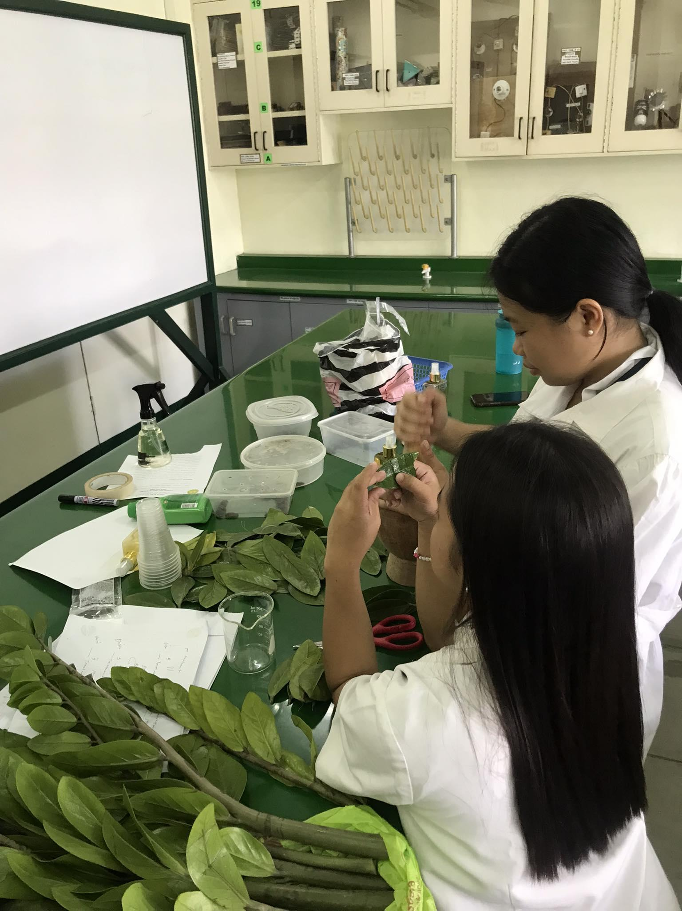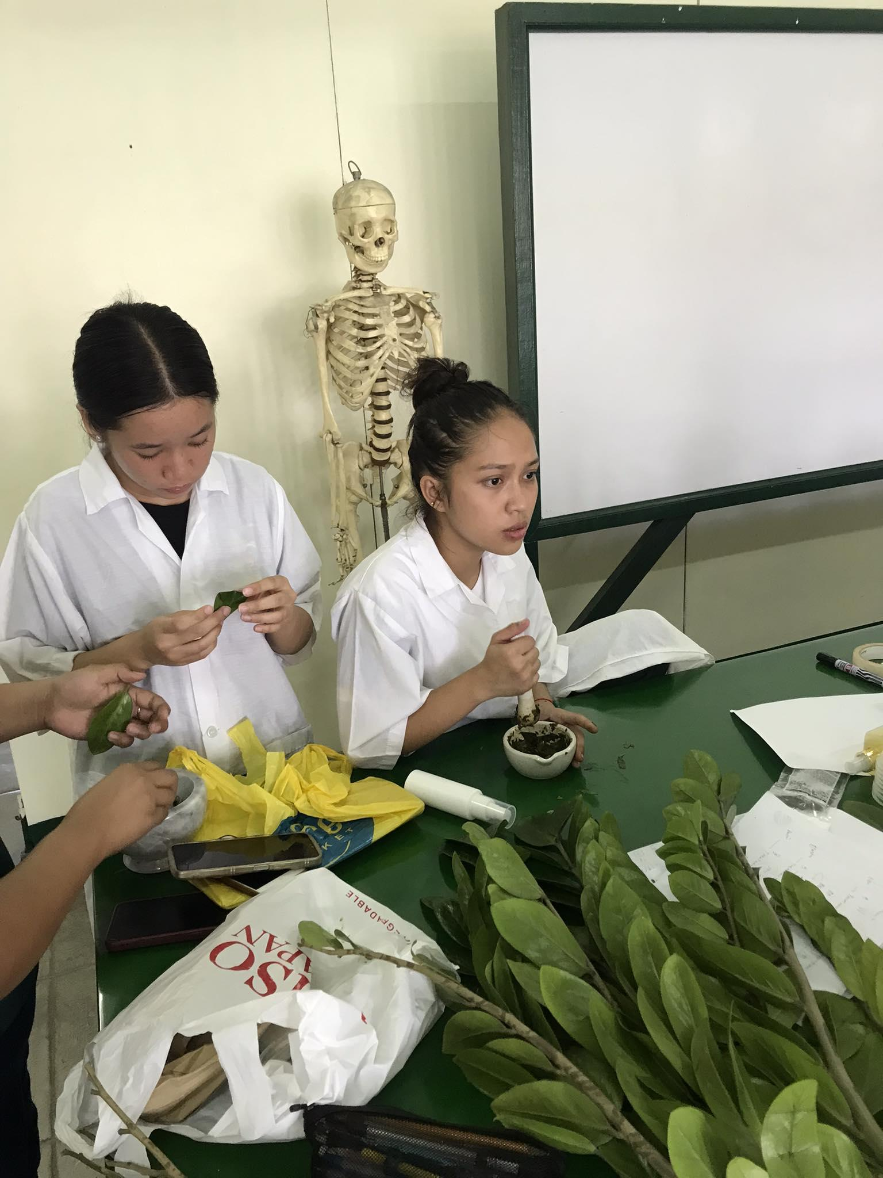

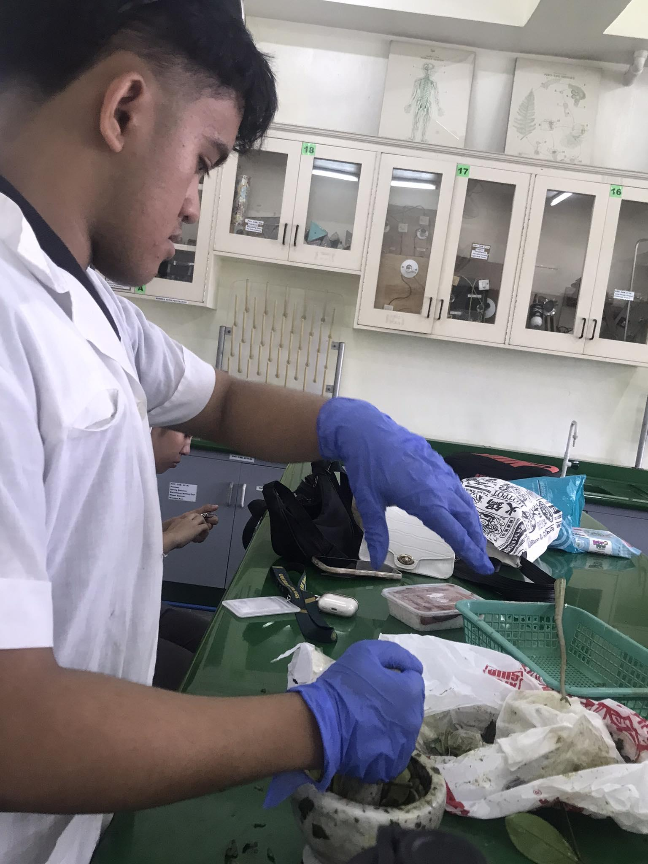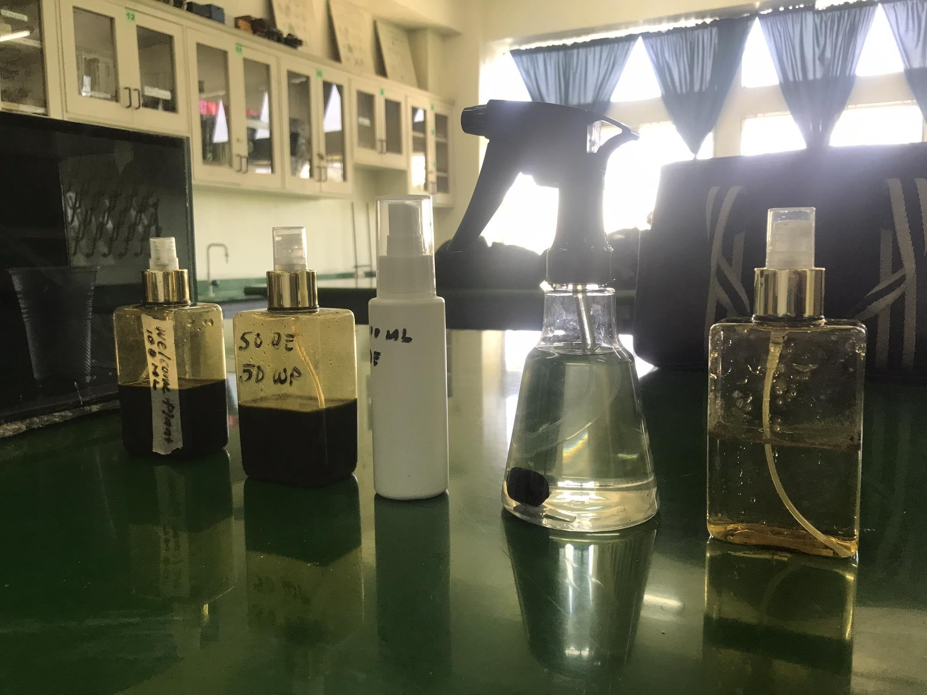

Researcher’s Profile

Name: Hallara, Elaizha Louise J. Hallara

Address: Brgy. Mali-ao, Pavia, Iloilo

Age: 18 years old

Email: hallaralouise575@gmail.com

Place of Birth: Jaro, Iloilo City

Date of Birth: May 7, 2005

Father: Eduardo Hallara y Andrade

Mother: Emma Jarina y Elmedorial

Educational Background:

Senior High School: Colegio de San Jose

Awards/Recognition: With Honors, Drum, lyre and Majorette Corp, Girl Scout of the Philippines, Children of Mary VMY,

Junior High School: Colegio de San Jose

Awards/Recognition: With Honors, Drum, lyre and Majorette Corp, Girl Scout of the Philippines, Children of Mary VMY,

Grade School: Colegio de San Jose

Awards/Recognition: With Honors, Drum, lyre and Majorette Corp, Girl Scout of the Philippines, Children of Mary VMY,

Kindergarten: Kid’s Home

Awards/Recognition:

Dream Profession: Nurse

Ideal Workplace:

Motto: “Don’t regret because you failed. Regret because you

never tried at all.”

Name: Elle, Vien Precious A.

Address: Villa Carolina Lapaz, Iloilo City

Age: 17 years old

Email: vielle0206@gmail.com

Place of Birth: Mandurriao , Iloilo City

Date of Birth: June 2, 2006

Father: Gevy Elle y Zaragoza

Mother: Wheng Villahermosa y Ambid

Educational Background:

Senior High School: Colegio de San Jose

Awards/Recognition: With Honors,

Junior High School: Colegio de San Jose

Awards/Recognition: With Honors

: Igbaras National Highschool

Awards/Recognition: With Honors,

Grade School: Colegio de San Jose

Awards/Recognition: With Honors

Kindergarten: Bright Minds Montessori

Awards/Recognition: With honors

Dream Profession: Pediatrician

Ideal Workplace:

Motto: “Don’t let what you cannot do interfere with what you can do .”

- John wooden

Name: Agacid,Bresias May y Ocheda

Address:0202 Monticello villas , balabag , pavia , Iloilo

Age:18

Email:bresiasmayagacid@gmail.com

Place of Birth: Goa , Camarines sur

Date of Birth: May 8 , 2005

Father: Agacid,Elmar y Nario

Mother:Agacid,Estelyn y Ocheda

Educational Background:

Senior High School: Colegio de San Jose

Junior High School: Colegio de San Jose

Grade School: Balabag Elementary School

Kindergarten: Calingao , Guimaras (forgot the school)

Dream Profession: Lieutenant or Engineer

Ideal Workplace: Camp Sight , Office

Motto:

"I think it’s possible for ordinary people to choose to be extraordinary.” —Elon Musk

Name: Malan,Andrea Marie y Gonzaga

Address: Sto. Domingo,Nueva Valencia, Guimaras

Age: 17 years old

Email: andreamariem11@gmail.com

Place of Birth: Dr. Catalino G. Nava Provincial Hospital

Date of Birth: October 11,2006

Father: Malan,Aniben y Galon

Mother: Malan,Rosie y Gonzaga

Educational Background:

Senior High School: Colegio de San Jose

Junior High School: Nueva Valencia National High School

With Honors

Grade School: Don Domingo Elementary School

With Honors

Kindergarten: Magamay Elementary School

Academic Excellence Award

Dream Profession: Nurse

Ideal Workplace:

Motto: “I can and I will.”

Name: Montaner, Kevin Benedict y Ortiz

Address: Sta Rosa North Subdivision Leganes

Age: 18 years old

Email: montanerk12@gmail.com

Place of Birth: Iloilo Mission Hospital Jaro, Iloilo City

Date of Birth: November 12,2005

Father: Montaner,Russell y Abrigo

Mother: Ortiz,Mardigrace y Osano

Educational Background:

Senior High School: Colegio de San Jose

Junior High School: Colegio de San Jose

Grade School: Colegio de San Jose

Kindergarten: The Growing tree learning center

Awards/Recognition:

Dream Profession: Physical therapist/Director

Ideal Workplace: office work and field work

Motto: "If one day the speed kills me, don't cry."

-Paul walker